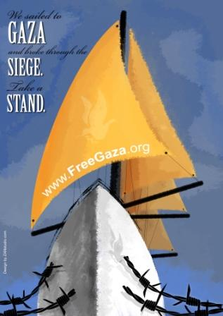
FOR IMMEDIATE RELEASE

HUMAN RIGHTS WORKERS TO ACCOMPANY
GAZA FISHERMEN ON MONDAY

For more information, please contact:
Gaza: Vittorio Arrigoni, +972 598 826 516
Gaza: Donna Wallach, +972 598 896 420 / FriendsOfGaza@gmail.com
Cyprus: Osama Qashoo, +357 97 793 595 / OsamaQashoo@gmail.com

GAZA CITY (1 September 2008) - Human Rights Observers from the Free Gaza Movement and the International Solidarity Movement launch campaign to monitor Israeli naval aggression against Gazan fishermen.

According to a recent article in The Guardian, "Under the Oslo accords, which in 1993 were supposed to herald the coming of an independent Palestinian state, Gazan fishermen were to be allowed 20 nautical miles out to sea, where they could catch sardine as they migrated from the Nile delta up towards Turkey during the spring. But Israeli naval ships in recent years have imposed their own, much-reduced limits, sometimes fewer than 6 miles out." Israel enforces these arbitrary limits with lethal violence. Many fishermen have either been killed or injured as a result. Just 3 days ago 4 such fishermen were attacked and “arrested” by Israeli gunboats.

This Monday morning, human rights workers from the Free Gaza Movement will accompany fishermen from Gaza City as they venture out to assert their right to fish their own coastal waters. The aim of these internationals will be to record and document the continued harassment of the Palestinian fishermen, and the arbitrary attacks and threats to which they are subjected. It is hoped that their presence will also act as some form of deterrent to these abuses.

The scope of the campaign extends beyond Gaza City all the way along Gaza’s coast. Human Rights Workers may be present on any Gazan fishing boat, at any time from this point onward. The boats on which they are present will not be specially marked.

###

http://www.FreeGaza.org

